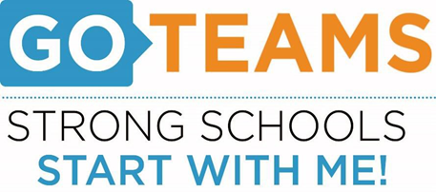

**MEETING NOTICE**

|  |  |  |  |
| --- | --- | --- | --- |
| **School** | **Date** | **Time** | **Location** |
| John Wesley Dobbs | January 24, 2024 | 4:00pm – 6:00pm | [**https://atlantapublicschools-us.zoom.us/j/86844117045?pwd=bWxoZ0FQNktIVndtWXY2Mm4yVEtTdz09**](https://atlantapublicschools-us.zoom.us/j/86844117045?pwd=bWxoZ0FQNktIVndtWXY2Mm4yVEtTdz09)    **Meeting ID: 868 4411 7045**  **Passcode: GoTeam**  **Youtube: Dobbs Elementary**  **@dobbselementaryschool8427** |

**Notice Prepared By:** Sonja Yarbrough **Date Posted: 1/19/24 .**

**Meeting Agenda**

(*agenda may be amended*)

*This meeting will allow for Public Comment*

1. **Action Items** 
   1. **Approval of Agenda:**
   2. **Approval of Previous Minutes:**
2. **Discussion Items** 
   1. **Review Budget Development Process**
   2. **Budget Allocation Presentation**
3. **Information Items** 
   1. **Principal’s Report**
      1. Winter MAP Data
      2. Writing Data
      3. CCRPI and Turnaround Updates
      4. Review Previously Ranked Strategic Priorities
4. **Announcements**
   1. Title I Family Engagement/Bingo Night – Jan. 24th @ 4:00pm-6:00pm
   2. Principal’s Celebration for Students – Jan. 26th
   3. Academic Family Engagement Night – Feb. 1st @ 4:00pm-6:00pm
   4. Dobbs Food Pantry – Feb. 7th @ 3:00pm – 5:00pm
   5. Science Fair – Feb. 13th
   6. Reading Buddies – Feb. 28th @ 11:00am – 12:00pm
   7. Black History Program – Mar. 1st
   8. Town Hall Meeting – Mar. 1st
5. **Public Comment**
6. **Adjournment**